Accounts Recievable Attachment Form 433-a

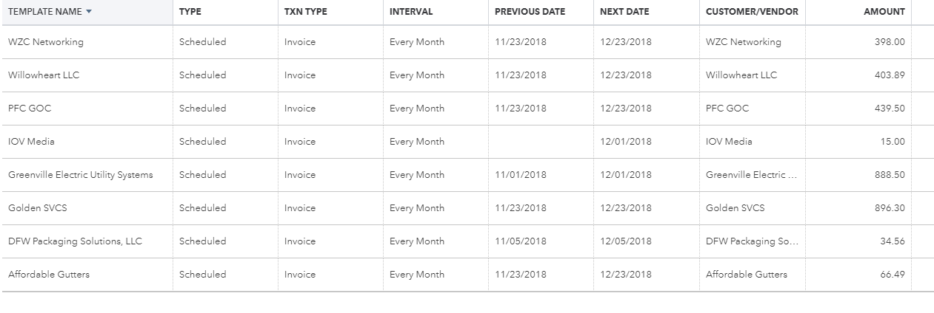

Total Monthly Income $3141.74